**Cassandra Key Space Operations, Table Operations & CURD**

**Keyspace:**

1. **What is keyspace?**

A keyspace is an object that holds the user defined type, column families, indexes, strategy (simple and network topology) and replication factor (number of replicas of data placed on different nodes).

1. **How to create a keyspace?**

cqlsh> create keyspace company with replication={'class':'SimpleStrategy', 'replication_factor':3};

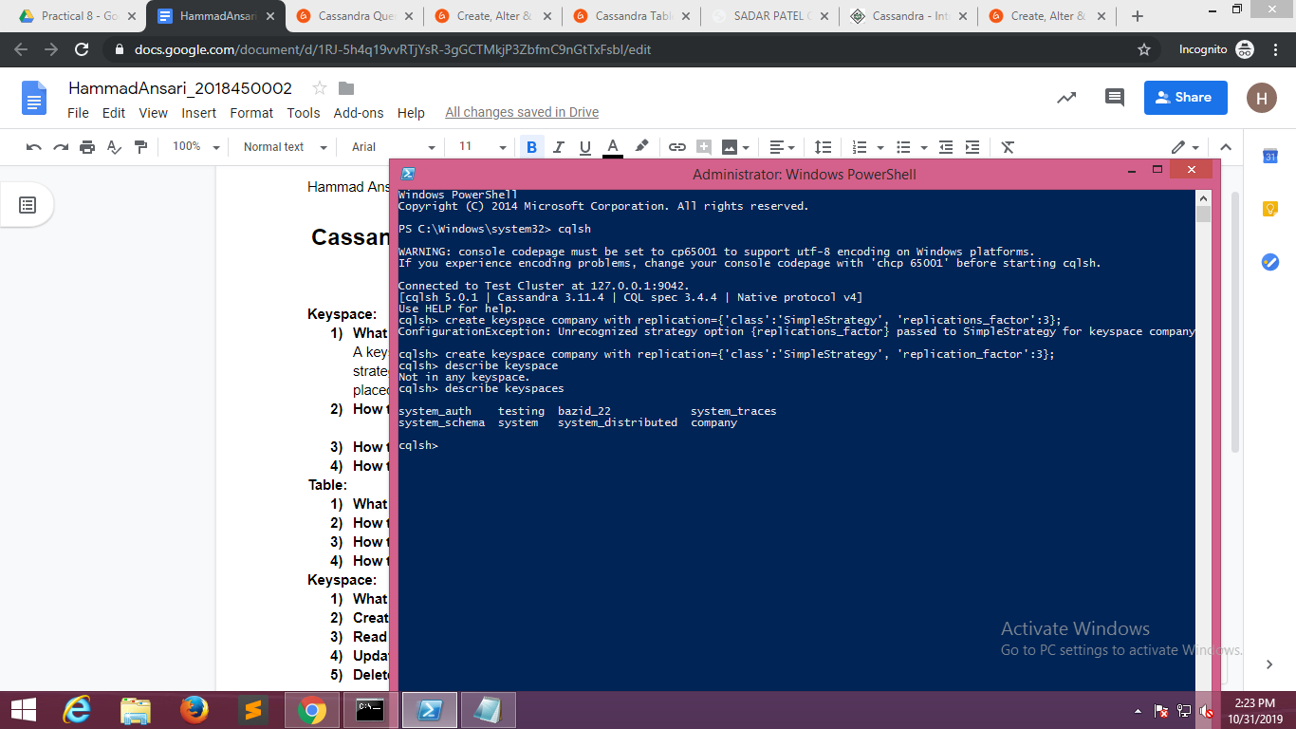

1. **How to alter a keyspace?**

cqlsh> alter keyspace testing with replication={'class':'SimpleStrategy', 'replication_factor':2};

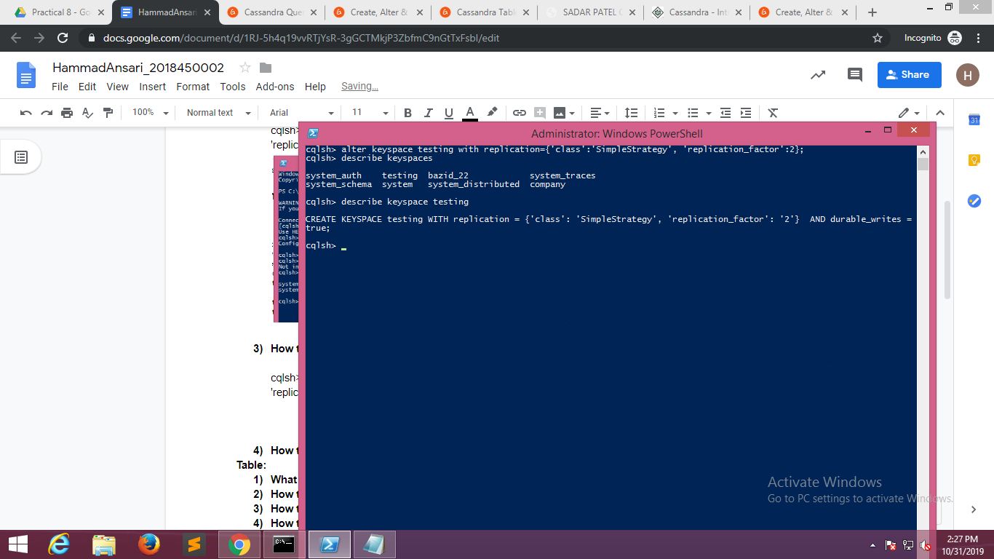

1. **How to drop a keyspace?**

cqlsh> Drop keyspace testing;

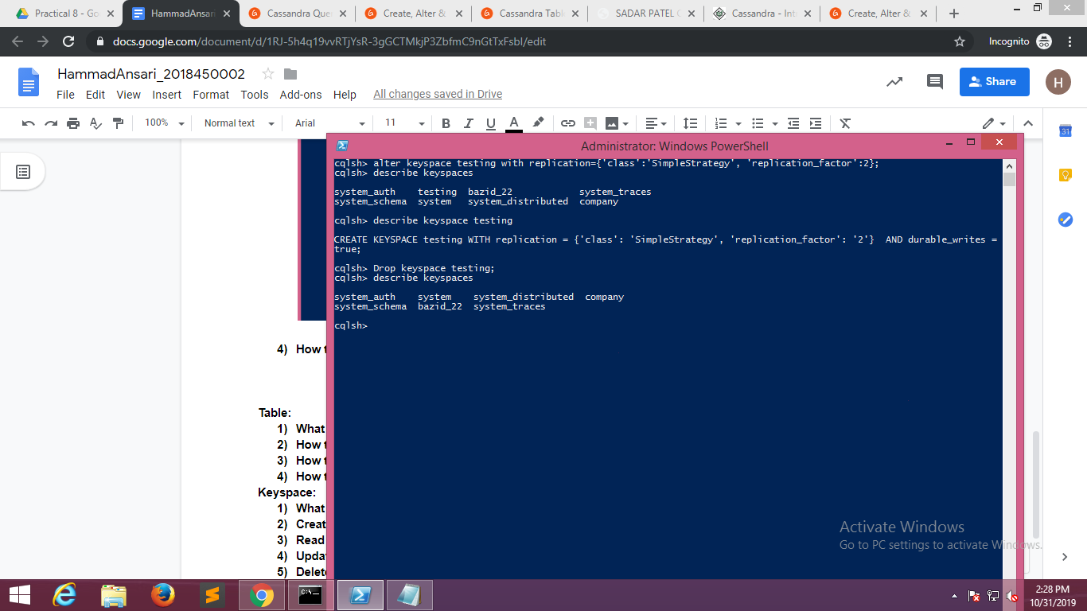

**Table:**

1. **What is table?**

Column family in Cassandra is similar to RDBMS table. Column family is used to store data.

1. **How to create a table?**

cqlsh:company> create table company.employee (Id int, Name text, sector text, salary int, desg text, primary key(Id) );

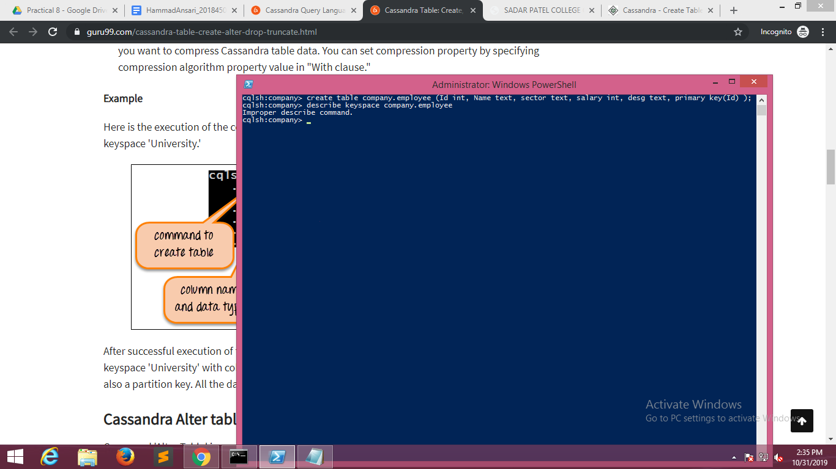

1. **How to alter a table?**

cqlsh:company> alter table company.employee

... Add job text;

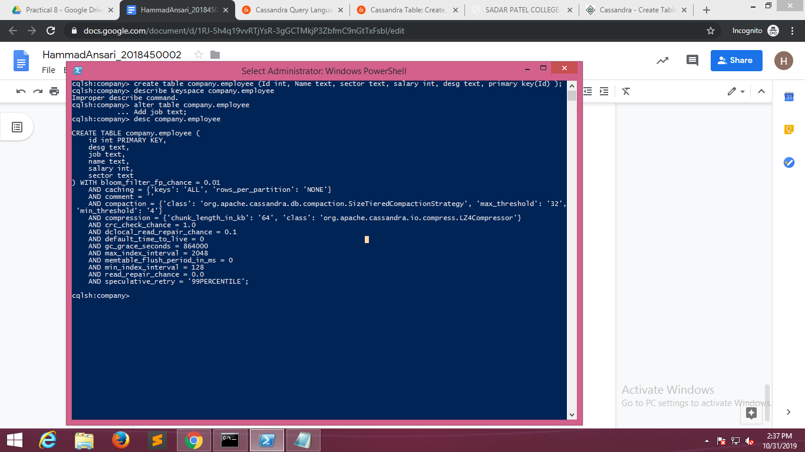

1. **How to truncate a table?**

cqlsh:company> truncate company.employee;

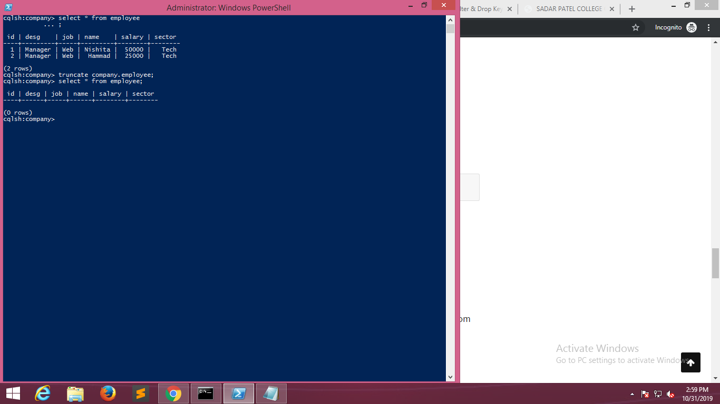

1. **How to drop a table?**

cqlsh:company> drop table company.employee;

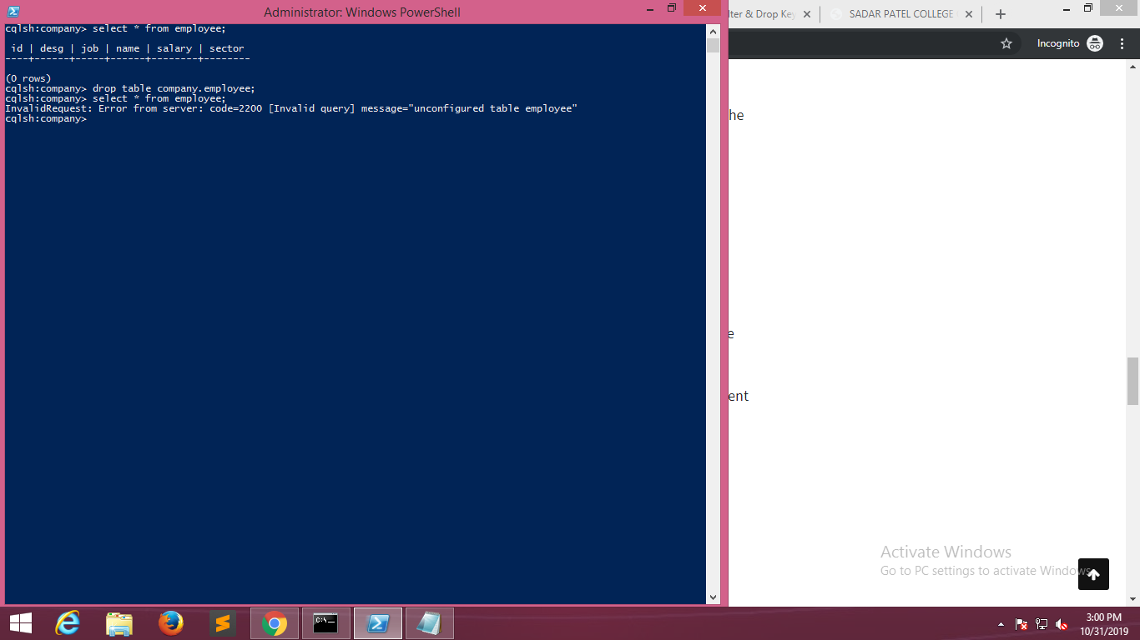

**Keyspace:**

1. **What is CRUD operation?**

The acronym CRUD stands for create, read, update and delete. These are four basic functions of persistent storage.

1. **Create:**

cqlsh:company> insert into company.employee(id, desg, job, name, salary, sector) values (2, 'Manager', 'Web', 'Michael',

... ;

cqlsh:company> insert into company.employee(id, desg, job, name, salary, sector) values (1, 'Manager', 'Web', 'Nishita',

50000, 'Tech');

cqlsh:company> insert into company.employee(id, desg, job, name, salary, sector) values (3, 'Manager', 'Product', 'Mauli

cqlsh:company>

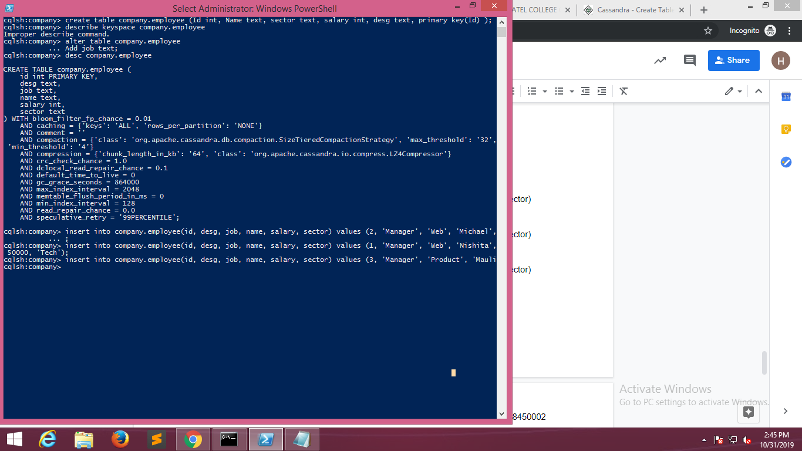

1. **Read:**

cqlsh:company> select * from employee ;

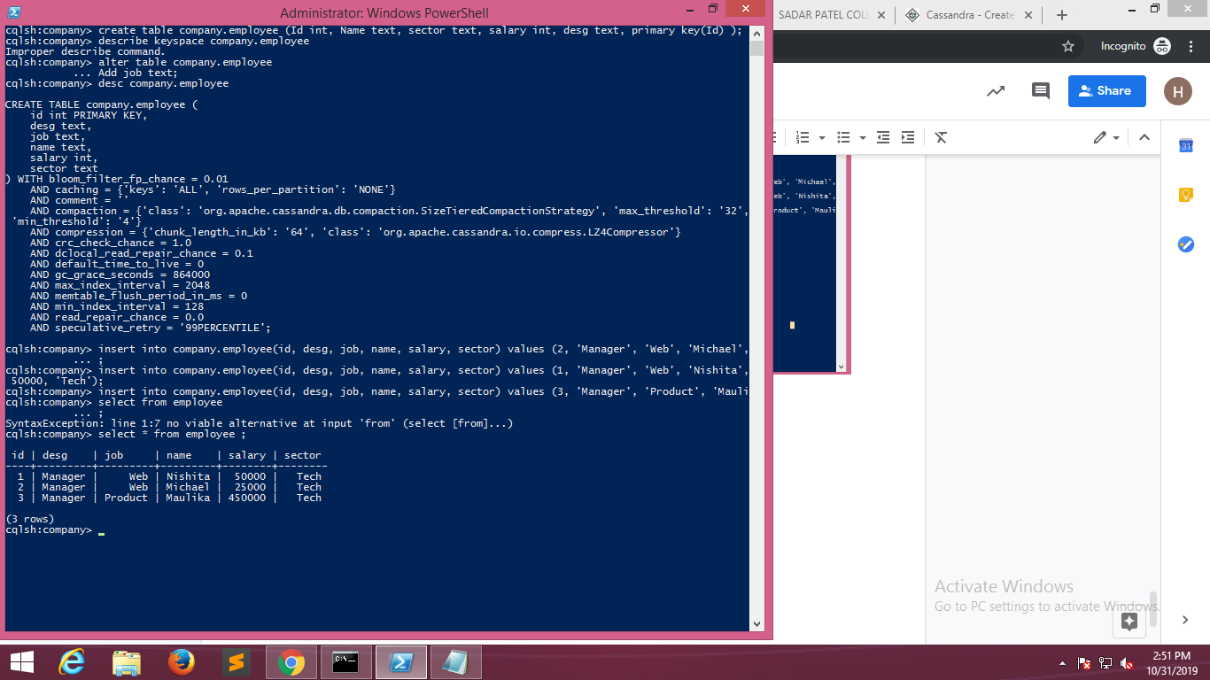

1. **Update:**

cqlsh:company> update company.employee

... set name='Hammad'

... where id = 2;

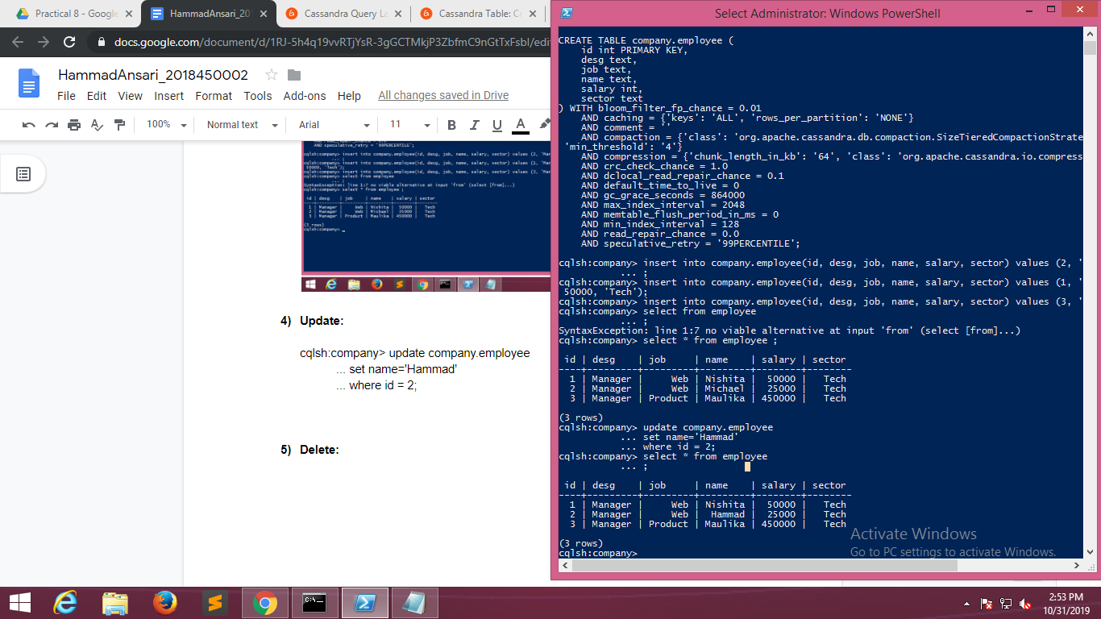

1. **Delete:**

cqlsh:company> delete from company.employee where id = 3;

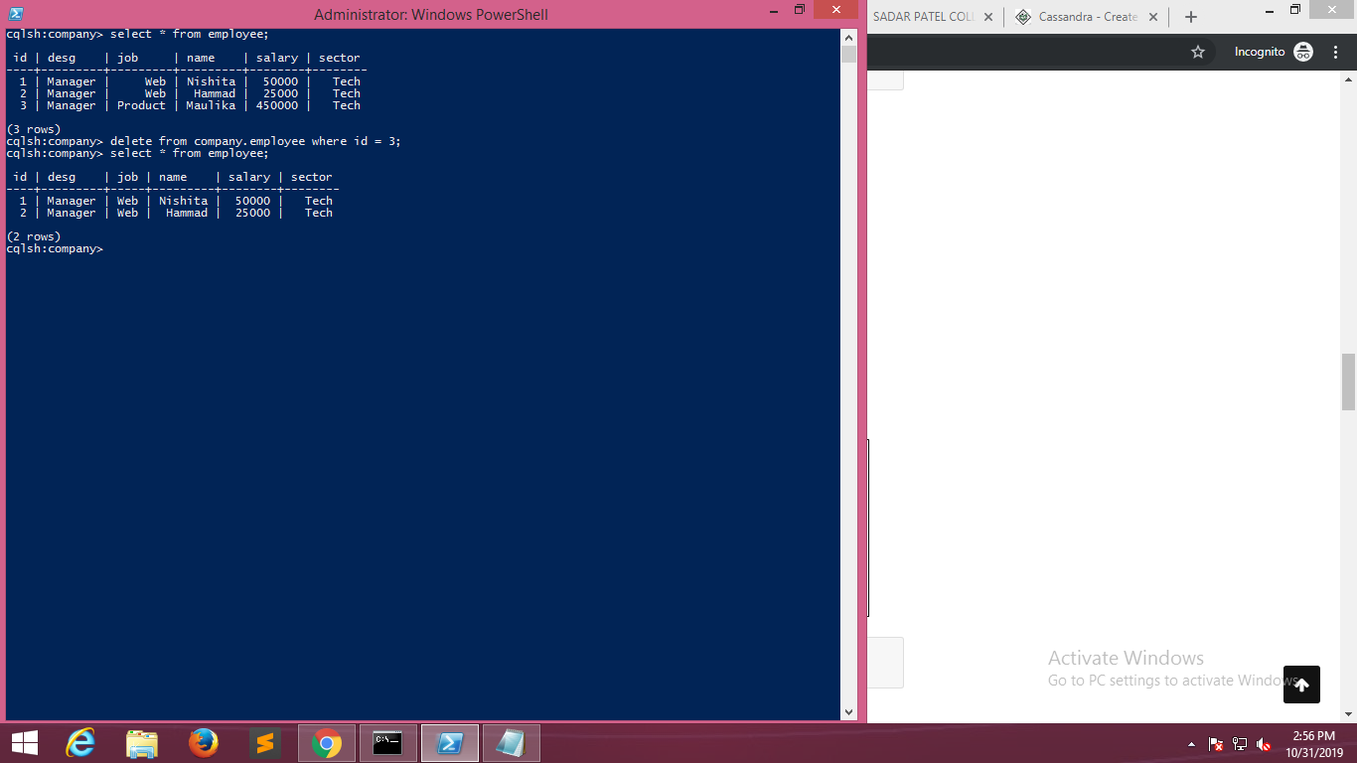

**Cassandra Database Connection:**

1. **Python Code:**

**First of all, we need to install Cassandra Drivers for python**

**pip install cassandra-driver**

**Code:**

**Connection.py**

**from cassandra.cluster import Cluster**

**if __name__ == "__main__":**

**cluster = Cluster(port=9042)**

**session = cluster.connect('company',wait_for_all_pools=True)**

**session.execute('USE company')**

**session.execute('insert into employee (id, desg, job, name, salary, sector) values (%s,%s,%s,%s,%s,%s)',(5,'Developer','Coding','Diksha',100000,'Tech'))**

**rows = session.execute('SELECT * FROM employee')**

**for row in rows:**

**print(row.id,row.desg,row.job,row.name,row.salary,row.sector)**

